**Connected Campus Crew**

Mark Girguis, Kishan Patel, Ankit Monga,

Eric Gonzalez, Jason Chung, Hector Khuon

**Deliverable 4**

**IS 436**

**5/9/19**

Splunk ERD

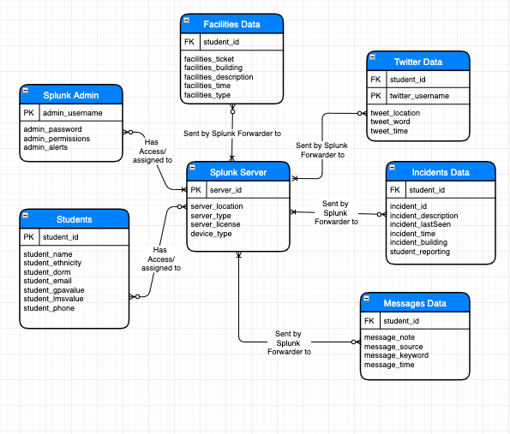

Alternative Matrix:

Public Website:

The public website will be available to all students and faculty throughout the campus.

Mobile App:

The mobile app will allow users to access connected campus on-the-go that hopefully will be accessible through the UMBC app.

Admin Website:

The admin website will allow administrators to access and manipulate the data through the Splunk queries.

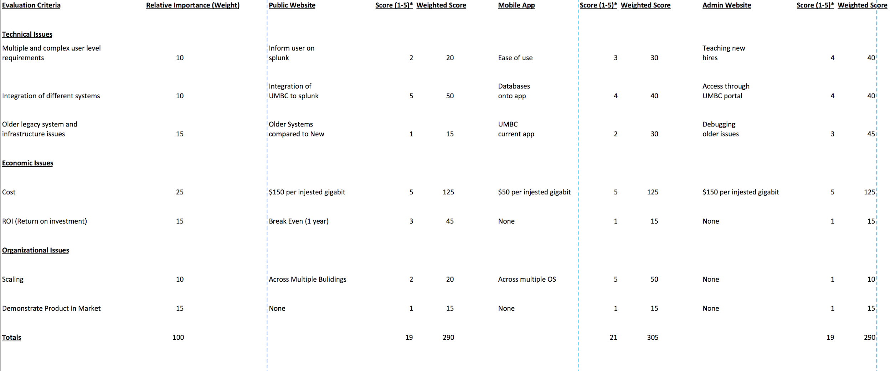

Operational Requirements

|  |  |
| --- | --- |
| **Requirement** | Definition |
| **Technical requirement** | Splunk Software |
| **System Integration** | The splunk software should be compatible with all mobile devices android and apple operating system. |
| **Portability** | The system will need to be accessed throughout the campus. |
| **Maintainability** | Have a dedicated Administrator look over the splunk dashboard and data. |

Performance Requirements

|  |  |
| --- | --- |
| **Requirement** | Definition |
| **Speed** | Time in which system works and info is delivered to user |
| **Capacity** | Total data accepted and volume of users. |
| **Reliability** | Extent to which the interface will be available to user no matter capacity and avoiding errors. |

Security Requirements

|  |  |
| --- | --- |
| **Requirement** | Definition |
| **System Value Estimates** | Estimated value of business and data |
| **Access Control** | Limit access depending on user |
| **Encryption and Authentication** | Defines what data is public and not encrypted and what data needs authentication and encryption |
| **Virus Control** | Control viruses and doesn’t allow them |

Cultural/political requirements

|  |  |
| --- | --- |
| **Requirement** | Definition |
| **Multilingual** | Different languages for users |
| **Customization** | Custom for experience for each user. |
| **Making Unstated Norms Explicit** | States things that will be different depending on the building you are visiting. |
| **Legal** | Laws are followed and user security is prevalent. |

Hardware and software specifications:

**Software requirements**

A single data collection node requires:

* A version of CentOS or RedHat Enterprise Linux (RHEL) that is compatible with one of the following:
* Splunk Enterprise 7.0 or later.
* A Splunk Enterprise heavy forwarder or light forwarder, version 7.0 or later. This is a minimum

**Hardware requirements**

* 4 cores - 4 vCPUs or 2 vCPUs with 2 cores with a reservation of 2 GHz
* 6GB memory with a reservation of 1 GB
* 4-10 GB of disk space
* Splunk requirement for the Splunk App for NetApp Data ONTAP. You cannot use a universal forwarder.

Project Plan:

